L&T Front End UI/UX

WAVES AND WONDERS

SUBMITTED BY:

Javaji teja sri -2460622

Sneha rohith -2460453

Nesha kirana raju -2460413

INSTRUCTOR NAME:

INSTITUTION:christ university

DATE OF SUBMISSION:11/08/25

ABSTRACT

The Waves & Wonders travel blog serves as an interactive platform for readers to explore captivating travel destinations, receive tips, and enjoy visually rich content. The design focuses on **responsiveness**, **attractive layouts**, and **easy navigation**, ensuring that users have a pleasant browsing experience across devices.

OBJECTIVES

* To design a visually appealing and easy-to-use travel blog.
* To provide travel enthusiasts with reliable tips and destination highlights.
* To build a fully responsive site that works on different screen sizes.
* To implement HTML, CSS, and JavaScript skills in a practical project.

SCOPE OF THE PROJECT

This blog targets travel lovers, bloggers, and tourists who seek inspiration and guidance. The project scope includes creating visually rich content, implementing responsive layouts, and structuring the website for easy updates. Future improvements may involve adding user-generated content, comment sections, and backend integration.

TOOLS AND TECHNOLOGIES USED

The following technologies were used in the development of the blog:

* **HTML5** – Structure of the web pages.
* **CSS3** – Styling, typography, and responsive design.
* **JavaScript** – Interactive features and dynamic elements.

HTML STRUCTURE OVERVIEW

The blog uses a **semantic HTML structure** including:

* <header> – Blog title and navigation bar.
* <nav> – Menu links to various sections.
* <section> – Main content areas for destinations and tips.
* <footer> – Contact information and credits.

CSS STYLING STATERGY

The CSS focuses on:

* A **consistent color palette** matching the travel theme.
* **Typography** that enhances readability.
* **Flexbox and Grid** for layout management.
* **Media queries** for response,

KEY FEATURES

Aesthetic and **user-friendly interface**.  
**Responsive design** for mobile, tablet, and desktop.  
**Navigation menu** for easy access to different pages.  
Attractive **imagery and typography**.  
Well-structured content for smooth reading.

CHALLENGES FACED AND SOLUTIONS

|  |  |
| --- | --- |
| **Challenge** | **Solution** |
| *Maintaining responsiveness across multiple devices. | *Used **CSS media queries** and flexible layouts. |
| *Optimizing image load time. | *Compressed images without losing quality. |
| *Keeping design consistent across pages. | *Created a style guide and reusable CSS classes. |

SAMPLE CODE

Below are the code snippets used in buildings the waves and wonders webpage,showcasing the HTML structure and CSS styling.

ABOUT

**<!DOCTYPE html>**

**<html lang="en">**

**<head>**

**<meta charset="UTF-8">**

**<meta name="viewport" content="width=device-width, initial-scale=1.0">**

**<title>About Us - Waves & Wonders</title>**

**<link href="https://fonts.googleapis.com/css2?family=Pacifico&family=Nunito:wght@400;600;700&display=swap" rel="stylesheet">**

**<style>**

**\* {margin: 0; padding: 0; box-sizing: border-box;}**

**body {**

**font-family: 'Nunito', sans-serif;**

**background-color: #fff9f4;**

**color: #333;**

**line-height: 1.6;**

**}**

**.container {**

**width: 90%;**

**max-width: 1100px;**

**margin: auto;**

**}**

**/* Header */**

**header {**

**background: white;**

**padding: 20px 0;**

**border-bottom: 1px solid #f1f1f1;**

**}**

**.header-content { display: flex;**

**justify-content: space-between;**

**align-items: center;**

**}**

**.logo {**

**font-family: 'Pacifico', cursive;**

**font-size: 1.8rem;**

**color: #e66b2e;**

**}**

**nav ul {**

**list-style: none;**

**display: flex;**

**gap: 1.5rem;**

**}**

**nav a {**

**text-decoration: none;**

**color: #777;**

**font-weight: 600;**

**transition: color 0.2s ease;**

**}**

**nav a.active {**

**color: #e66b2e;**

**}**

**nav a:hover {**

**color: #e66b2e;**

**}**

**/* About Section */**

**.about {**

**display: flex;**

**flex-wrap: wrap;**

**align-items: center;**

**gap: 2rem;**

**padding: 3rem 0;**

**}**

**.about img {**

**flex: 1 1 300px;**

**max-width: 350px;**

**border-radius: 12px;**

**box-shadow: 0 6px 15px rgba(230, 107, 46, 0.2);**

**}**

**.about-content {**

**flex: 2 1 500px;**

**}**

**.about-content h2 {**

**font-size: 2rem;**

**font-weight: 700;**

**color: #e66b2e;**

**margin-bottom: 1rem;**

**}**

**.about-content p {**

**margin-bottom: 1rem;**

**font-size: 1.05rem;**

**color: #444;**

**}**

**/* Discover Section */**

**.discover {**

**background: #ffece0;**

**padding: 2rem;**

**border-radius: 12px;**

**margin: 2rem 0;**

**}**

**.discover h3 {**

**color: #e66b2e;**

**font-size: 1.4rem;**

**margin-bottom: 1rem;**

**}**

**.discover ul {**

**list-style: none;**

**padding-left: 0;**

**}**

**.discover li {**

**margin-bottom: 0.5rem;**

**font-size: 1rem;**

**}**

**/* Collaborate Section */**

**.collaborate {**

**text-align: center;**

**padding: 2rem 0;**

**}**

**.collaborate h3 {**

**color: #e66b2e;**

**font-size: 1.6rem;**

**margin-bottom: 1rem;**

**}**

**.btn {**

**background: #e66b2e;**

**color: white;**

**padding: 0.8rem 1.6rem;**

**border-radius: 8px;**

**text-decoration: none;**

**font-weight: 700;**

**transition: background 0.3s ease;**

**}**

**.btn:hover {**

**background: #cc5c20;**

**}**

**/* Footer */**

**footer {**

**background: white;**

**border-top: 1px solid #f1f1f1;**

**padding: 1.5rem 0;**

**margin-top: 2rem;**

**text-align: center;**

**}**

**footer p {**

**color: #555;**

**font-size: 0.95rem;**

**}**

**</style>**

**</head>**

**<body>**

**<header>**

**<div class="container header-content">**

**<h1 class="logo">Waves & Wonders</h1>**

**<nav>**

**<ul>**

**<li><a href="index.html">Home</a></li>**

**<li><a href="about.html" class="active">About</a></li>**

**<li><a href="destinations.html">Destinations</a></li>**

**<li><a href="blog.html">Blog</a></li>**

**<li><a href="contact.html">Contact</a></li>**

**</ul>**

**</nav>**

**</div>**

**</header>**

**<div class="container about">**

**<img src="images/maya.jpg" alt="Maya - Founder" />**

**<div class="about-content">**

**<h2>Hi, I'm Maya</h2>**

**<p>I’m the voice behind <strong>Waves & Wonders</strong>, a space where stories, guides, and visual journals come together to celebrate the magic of meaningful travel.</p>**

**<p>From the aroma of fresh bread in a sleepy coastal town to the dazzling colors of a sunrise market, I write to preserve the quiet moments that make journeys unforgettable.</p>**

**<p>Here, you’ll find inspiration for slow travel, authentic experiences, and practical tips you can trust.</p>**

**</div>**

**</div>**

**<div class="container discover">**

**<h3>What You’ll Discover Here</h3>**

**<ul>**

**<li>📷 Curated photo destination guides</li>**

**<li>🗺️ Well-researched travel itineraries</li>**

**<li>🎒 Smart packing tips & budget-friendly advice</li>**

**</ul>**

**</div>**

**<div class="container collaborate">**

**<h3>Let’s Collaborate</h3>**

**<p>If you’re a brand, fellow traveler, or storyteller — let’s work together to create something beautiful.</p>**

**<a href="contact.html" class="btn">Get in Touch</a>**

**</div>**

**<footer>**

**<div class="container">**

**<strong>Waves & Wonders</strong>**

**<p>Travel stories, guides & adventures — built with HTML &amp; CSS.</p>**

**</div>**

**</footer>**

**</body>**

**</html>**

**BALI**

**<!DOCTYPE html>**

**<html lang="en">**

**<head>**

**<meta charset="UTF-8" />**

**<meta name="viewport" content="width=device-width, initial-scale=1" />**

**<title>48 Hours in Bali - Waves & Wonders</title>**

**<link href="https://fonts.googleapis.com/css2?family=Pacifico&family=Nunito:wght@400;600;700&display=swap" rel="stylesheet">**

**<style>**

**body { font-family: 'Nunito', sans-serif; background: #fff6f1; color: #333; margin: 2rem auto; max-width: 700px; }**

**h1 { font-family: 'Pacifico', cursive; color: #00bfa6; margin-bottom: 1rem;}**

**a { color: #00bfa6; text-decoration: none; font-weight: 600; }**

**a:hover { text-decoration: underline; }**

**p { line-height: 1.6; margin-bottom: 1rem; }**

**</style>**

**</head>**

**<body>**

**<a href="blog.html">← Back to Blog</a>**

**<h1>48 Hours in Bali</h1>**

**<p><em>June 12, 2025 · 6 min read</em></p>**

**<p>Welcome to your quick itinerary for Bali. Discover the best beaches, temples, and cafes to make your short trip unforgettable...</p>**

**<h2>Day 1: Beaches & Sunsets</h2>**

**<p>Start your morning at Kuta Beach, then head to Uluwatu Temple for breathtaking views...</p>**

**<h2>Day 2: Temples & Local Cafes</h2>**

**<p>Explore Tanah Lot and end your day at a charming café in Seminyak...</p>**

**<p>Enjoy your trip!</p>**

**</body>**

**</html>**

**BLOG GUIDE**

**<!DOCTYPE html>**

**<html lang="en">**

**<head>**

**<meta charset="UTF-8" />**

**<meta name="viewport" content="width=device-width, initial-scale=1" />**

**<title>48 Hours in Bali — A Beginner's Guide | Waves & Wonders</title>**

**<link href="https://fonts.googleapis.com/css2?family=Pacifico&family=Nunito:wght@400;600;700&display=swap" rel="stylesheet" />**

**<style>**

**body {**

**font-family: 'Nunito', sans-serif;**

**background-color: #fff9f4;**

**color: #333;**

**max-width: 700px;**

**margin: 2rem auto;**

**padding: 1rem;**

**}**

**h1 {**

**color: #e66b2e;**

**margin-bottom: 0.5rem;**

**}**

**p.date-author {**

**font-size: 0.9rem;**

**color: #777;**

**margin-bottom: 2rem;**

**}**

**a.back-link {**

**display: inline-block;**

**margin-top: 2rem;**

**color: #e66b2e;**

**text-decoration: none;**

**font-weight: 700;**

**}**

**a.back-link:hover {**

**text-decoration: underline;**

**}**

**</style>**

**</head>**

**<body>**

**<h1>48 Hours in Bali — A Beginner's Guide</h1>**

**<p class="date-author">Published on August 9, 2025 by Waves & Wonders</p>**

**<p>Welcome to Bali! This guide will help you make the most out of your short trip to this tropical paradise. From visiting sunrise temples to exploring lush rice terraces and enjoying the best beach clubs, here’s how to spend 48 unforgettable hours in Bali.</p>**

**<h2>Day 1: Explore Temples and Rice Terraces</h2>**

**<p>Start your day early with a visit to the famous Tanah Lot Temple, then head to the Tegallalang Rice Terraces for stunning views and great photo ops.</p>**

**<h2>Day 2: Beach Time and Sunset</h2>**

**<p>Relax at Seminyak Beach and enjoy the vibrant beach clubs. Don’t miss the sunset at Uluwatu Temple — it’s magical!</p>**

**<a href="index.html" class="back-link">← Back to Home</a>**

**</body>**

**</html>**

**BLOG**

**<!DOCTYPE html>**

**<html lang="en">**

**<head>**

**<meta charset="UTF-8">**

**<meta name="viewport" content="width=device-width, initial-scale=1.0">**

**<title>Blog - Waves & Wonders</title>**

**<link href="https://fonts.googleapis.com/css2?family=Pacifico&family=Nunito:wght@400;600;700&display=swap" rel="stylesheet">**

**<style>**

**\* {margin: 0; padding: 0; box-sizing: border-box;}**

**body {**

**font-family: 'Nunito', sans-serif;**

**background-color: #fff6f1; /* soft peach */**

**color: #333;**

**line-height: 1.6;**

**}**

**.container {**

**width: 90%;**

**max-width: 1100px;**

**margin: auto;**

**}**

**/* Header */**

**header {**

**background: white;**

**padding: 20px 0;**

**border-bottom: 1px solid #f1f1f1;**

**}**

**.header-content {**

**display: flex;**

**justify-content: space-between;**

**align-items: center;**

**}**

**.logo {**

**font-family: 'Pacifico', cursive;**

**font-size: 1.8rem;**

**color: #ff7b54; /* orange accent */**

**}**

**nav ul {**

**list-style: none;**

**display: flex;**

**gap: 1.5rem;**

**}**

**nav a {**

**text-decoration: none;**

**color: #777;**

**font-weight: 600;**

**transition: color 0.2s ease;**

**}**

**nav a.active {**

**color: #ff7b54; /* orange accent */**

**}**

**nav a:hover {**

**color: #ff7b54;**

**}**

**/* Blog Section */**

**main {**

**padding: 2rem 0;**

**}**

**main h2 {**

**font-size: 2rem;**

**font-weight: 700;**

**margin-bottom: 0.5rem;**

**color: #ff7b54; /* orange title */**

**}**

**.subtitle {**

**color: #777;**

**margin-bottom: 2rem;**

**}**

**/* Blog Cards */**

**.blog-grid {**

**display: grid;**

**grid-template-columns: repeat(auto-fit, minmax(280px, 1fr));**

**gap: 1.5rem;**

**}**

**.blog-card {**

**background: white;**

**border-radius: 12px;**

**overflow: hidden;**

**box-shadow: 0 4px 10px rgba(0,0,0,0.05);**

**display: flex;**

**flex-direction: column;**

**transition: transform 0.2s ease, box-shadow 0.2s ease;**

**}**

**.blog-card:hover {**

**transform: translateY(-5px);**

**box-shadow: 0 6px 15px rgba(255, 123, 84, 0.2);**

**}**

**.blog-card img {**

**width: 100%;**

**height: 160px;**

**object-fit: cover;**

**display: block;**

**}**

**.blog-card-content {**

**padding: 1rem;**

**flex: 1;**

**}**

**.blog-card-content h3 {**

**font-size: 1.1rem;**

**margin-bottom: 0.3rem;**

**color: #ff7b54; /* orange heading */**

**}**

**.blog-meta {**

**font-size: 0.85rem;**

**color: #999;**

**margin-bottom: 0.8rem;**

**}**

**.blog-card-content p {**

**font-size: 0.95rem;**

**margin-bottom: 0.8rem;**

**}**

**.read-more {**

**color: #ff7b54; /* orange link */**

**font-weight: 600;**

**text-decoration: none;**

**}**

**.read-more:hover {**

**text-decoration: underline;**

**}**

**/* Footer */**

**footer {**

**background: white;**

**border-top: 1px solid #f1f1f1;**

**padding: 1.5rem 0;**

**margin-top: 2rem;**

**text-align: center;**

**}**

**footer p {**

**color: #555;**

**font-size: 0.95rem;**

**}**

**</style>**

**</head>**

**<body>**

**<header>**

**<div class="container header-content">**

**<h1 class="logo">Waves & Wonders</h1>**

**<nav>**

**<ul>**

**<li><a href="home.html">Home</a></li>**

**<li><a href="about.html">About</a></li>**

**<li><a href="destinations.html">Destinations</a></li>**

**<li><a href="blog.html" class="active">Blog</a></li>**

**<li><a href="contact.html">Contact</a></li>**

**</ul>**

**</nav>**

**</div>**

**</header>**

**<main class="container">**

**<h2>Blog</h2>**

**<p class="subtitle">Latest guides, photo essays and travel tips.</p>**

**<div class="blog-grid">**

**<!-- Card 1 -->**

**<div class="blog-card">**

**<img src="images/balilast.jpeg" alt="Bali">**

**<div class="blog-card-content">**

**<h3>48 Hours in Bali</h3>**

**<div class="blog-meta">June 12, 2025 · 6 min read</div>**

**<p>Quick itinerary with beaches, temples and cafes for a short trip.</p>**

**<a href="bali.html" class="read-more">Continue reading →</a>**

**</div>**

**</div>**

**<!-- Card 2 -->**

**<div class="blog-card">**

**<img src="images/picnic.jpeg" alt="Picnic">**

**<div class="blog-card-content">**

**<h3>Best Picnic Spots on the Coast</h3>**

**<div class="blog-meta">May 04, 2025 · 4 min read</div>**

**<p>A list of secret coves and easy lunch ideas for a day out.</p>**

**<a href="picnic.html" class="read-more">Continue reading →</a>**

**</div>**

**</div>**

**<!-- Card 3 -->**

**<div class="blog-card">**

**<img src="images/download.jpeg" alt="Packing">**

**<div class="blog-card-content">**

**<h3>Packing Light: My Capsule List</h3>**

**<div class="blog-meta">March 18, 2025 · 5 min read</div>**

**<p>How to pack for two weeks in a carry-on bag.</p>**

**<a href="packing.html" class="read-more">Continue reading →</a>**

**</div>**

**</div>**

**</div>**

**</main>**

**<footer>**

**<div class="container">**

**<strong>Waves & Wonders</strong>**

**<p>travell travel nd TRAVELLL</p>**

**</div>**

**</footer>**

**</body>**

**</html>**

**COASTAL ROAD TRIP**

**<!DOCTYPE html>**

**<html lang="en">**

**<head>**

**<meta charset="UTF-8" />**

**<meta name="viewport" content="width=device-width, initial-scale=1" />**

**<title>Coastal Road Trip: The Hidden Gems | Waves & Wonders</title>**

**<link href="https://fonts.googleapis.com/css2?family=Pacifico&family=Nunito:wght@400;600;700&display=swap" rel="stylesheet" />**

**<style>**

**body {**

**font-family: 'Nunito', sans-serif;**

**background-color: #fff9f4;**

**color: #333;**

**max-width: 800px;**

**margin: 2rem auto;**

**padding: 1rem 2rem;**

**}**

**h1 {**

**color: #e66b2e;**

**margin-bottom: 0.5rem;**

**}**

**p.date-author {**

**font-size: 0.9rem;**

**color: #777;**

**margin-bottom: 2rem;**

**}**

**h2 {**

**margin-top: 1.5rem;**

**color: #cc5c20;**

**}**

**p {**

**line-height: 1.6;**

**margin-bottom: 1rem;**

**}**

**a.back-link {**

**display: inline-block;**

**margin-top: 2rem;**

**color: #e66b2e;**

**text-decoration: none;**

**font-weight: 700;**

**}**

**a.back-link:hover {**

**text-decoration: underline;**

**}**

**</style>**

**</head>**

**<body>**

**<h1>Coastal Road Trip: The Hidden Gems</h1>**

**<p class="date-author">Published on August 9, 2025 by Waves & Wonders</p>**

**<p>Embarking on a coastal road trip is one of the best ways to experience the beauty and charm of hidden gems along the shore. Whether you’re a seasoned traveler or a weekend adventurer, this guide will help you plan a relaxing and scenic journey.</p>**

**<h2>Planning Your Route</h2>**

**<p>Start by mapping out key stops, prioritizing small towns, scenic viewpoints, and local eateries. Avoid major highways when possible to enjoy the coastal views and quaint vibes.</p>**

**<h2>Must-Visit Stops</h2>**

**<ul>**

**<li><strong>Seaside Village:</strong> A charming town known for its artisan shops and fresh seafood markets.</li>**

**<li><strong>Cliffside Lookout:</strong> Offers breathtaking panoramic views of the ocean and is perfect for a picnic.</li>**

**<li><strong>Hidden Cove:</strong> A quiet beach spot with crystal-clear water, ideal for swimming and snorkeling.</li>**

**</ul>**

**<h2>Food & Snacks</h2>**

**<p>Pack a picnic basket with local treats or stop at roadside stands offering fresh fruits and homemade pastries. Don’t miss the opportunity to try the regional specialties at family-run diners.</p>**

**<h2>Tips for a Smooth Trip</h2>**

**<ul>**

**<li>Check your vehicle before the trip — tire pressure, oil, and fuel.</li>**

**<li>Bring plenty of water and sun protection.</li>**

**<li>Download offline maps to stay connected in areas with poor reception.</li>**

**<li>Take your time and enjoy spontaneous stops along the way.</li>**

**</ul>**

**<p>Remember, the joy of a road trip is in the journey itself — so slow down, take photos, and soak in the coastal magic.</p>**

**<a href="index.html" class="back-link">← Back to Home</a>**

**</body>**

**</html>**

**CONTACT**

**<!DOCTYPE html>**

**<html lang="en">**

**<head>**

**<meta charset="UTF-8" />**

**<meta name="viewport" content="width=device-width, initial-scale=1.0" />**

**<title>Contact Us - Waves & Wonders</title>**

**<link href="https://fonts.googleapis.com/css2?family=Pacifico&family=Nunito:wght@400;600;700&display=swap" rel="stylesheet" />**

**<style>**

**\* {**

**box-sizing: border-box;**

**margin: 0;**

**padding: 0;**

**}**

**body {**

**font-family: 'Nunito', sans-serif;**

**background-color: #fff9f4;**

**color: #333;**

**line-height: 1.6;**

**}**

**.container {**

**width: 90%;**

**max-width: 1100px;**

**margin: 2rem auto;**

**}**

**header {**

**background: white;**

**padding: 20px 0;**

**border-bottom: 1px solid #f1f1f1;**

**}**

**.header-content {**

**display: flex;**

**justify-content: space-between;**

**align-items: center;**

**}**

**.logo {**

**font-family: 'Pacifico', cursive;**

**font-size: 1.8rem;**

**color: #e66b2e;**

**}**

**nav ul {**

**list-style: none;**

**display: flex;**

**gap: 1.5rem;**

**}**

**nav a {**

**text-decoration: none;**

**color: #777;**

**font-weight: 600;**

**transition: color 0.2s ease;**

**}**

**nav a.active {**

**color: #e66b2e;**

**}**

**nav a:hover {**

**color: #e66b2e;**

**}**

**h1.page-title {**

**font-size: 2.5rem;**

**color: #e66b2e;**

**margin-bottom: 1rem;**

**text-align: center;**

**}**

**.contact-section {**

**display: flex;**

**flex-wrap: wrap;**

**gap: 2rem;**

**margin-top: 2rem;**

**}**

**.contact-form {**

**flex: 1 1 500px;**

**background: white;**

**padding: 2rem;**

**border-radius: 12px;**

**box-shadow: 0 4px 10px rgba(0, 0, 0, 0.05);**

**}**

**.contact-form h2 {**

**color: #e66b2e;**

**margin-bottom: 1rem;**

**}**

**.contact-form label {**

**display: block;**

**margin-bottom: 0.5rem;**

**font-weight: 600;**

**}**

**.contact-form input,**

**.contact-form textarea {**

**width: 100%;**

**padding: 0.8rem;**

**margin-bottom: 1.5rem;**

**border: 1px solid #ccc;**

**border-radius: 8px;**

**font-family: 'Nunito', sans-serif;**

**}**

**.contact-form button {**

**background-color: #e66b2e;**

**color: white;**

**padding: 0.9rem 1.6rem;**

**border: none;**

**border-radius: 8px;**

**font-weight: 700;**

**cursor: pointer;**

**transition: background 0.3s ease;**

**box-shadow: 0px 4px 8px rgba(230, 107, 46, 0.4);**

**}**

**.contact-form button:hover {**

**background-color: #cc5c20;**

**}**

**.map {**

**flex: 1 1 500px;**

**border-radius: 12px;**

**overflow: hidden;**

**box-shadow: 0 4px 10px rgba(0, 0, 0, 0.05);**

**}**

**iframe {**

**width: 100%;**

**height: 100%;**

**border: none;**

**min-height: 400px;**

**}**

**footer {**

**background: white;**

**border-top: 1px solid #f1f1f1;**

**padding: 1.5rem 0;**

**margin-top: 3rem;**

**text-align: center;**

**}**

**footer p {**

**color: #555;**

**font-size: 0.95rem;**

**}**

**@media (max-width: 768px) {**

**.contact-section {**

**flex-direction: column;**

**}**

**}**

**</style>**

**</head>**

**<body>**

**<header>**

**<div class="container header-content">**

**<h1 class="logo">Waves & Wonders</h1>**

**<nav>**

**<ul>**

**<li><a href="index.html">Home</a></li>**

**<li><a href="about.html">About</a></li>**

**<li><a href="destinations.html">Destinations</a></li>**

**<li><a href="blog.html">Blog</a></li>**

**<li><a href="contact.html" class="active">Contact</a></li>**

**</ul>**

**</nav>**

**</div>**

**</header>**

**<div class="container">**

**<h1 class="page-title">Let's Get in Touch</h1>**

**<div class="contact-section">**

**<!-- Contact Form -->**

**<div class="contact-form">**

**<h2>Contact Us</h2>**

**<form action="#" method="POST">**

**<label for="name">Full Name</label>**

**<input type="text" id="name" name="name" required />**

**<label for="email">Email Address</label>**

**<input type="email" id="email" name="email" required />**

**<label for="message">Your Message</label>**

**<textarea id="message" name="message" rows="6" required></textarea>**

**<button type="submit">Send Message</button>**

**</form>**

**</div>**

**<!-- Interactive Google Map centered on India -->**

**<div class="map">**

**<iframe**

**src="https://maps.google.com/maps?q=india&t=&z=5&ie=UTF8&iwloc=&output=embed"**

**allowfullscreen**

**loading="lazy"**

**></iframe>**

**</div>**

**</div>**

**</div>**

**<footer>**

**<p>© 2025 Waves & Wonders. All rights reserved.</p>**

**</footer>**

**</body>**

**</html>**

**DESTINATION**

**<!DOCTYPE html>**

**<html lang="en">**

**<head>**

**<meta charset="UTF-8">**

**<meta name="viewport" content="width=device-width, initial-scale=1.0">**

**<title>Waves & Wonders - Destinations</title>**

**<link href="https://fonts.googleapis.com/css2?family=Pacifico&family=Nunito:wght@400;600;700&display=swap" rel="stylesheet">**

**<style>**

**\* {margin: 0; padding: 0; box-sizing: border-box;}**

**body {**

**font-family: 'Nunito', sans-serif;**

**background-color: #fff9f4;**

**color: #333;**

**line-height: 1.6;**

**}**

**.container {**

**width: 90%;**

**max-width: 1100px;**

**margin: auto;**

**}**

**/* Header */**

**header {**

**background: white;**

**padding: 20px 0;**

**border-bottom: 1px solid #f1f1f1;**

**}**

**.header-content {**

**display: flex;**

**justify-content: space-between;**

**align-items: center;**

**}**

**.logo {**

**font-family: 'Pacifico', cursive;**

**font-size: 1.8rem;**

**color: #e66b2e;**

**}**

**nav ul {**

**list-style: none;**

**display: flex;**

**gap: 1.5rem;**

**}**

**nav a {**

**text-decoration: none;**

**color: #777;**

**font-weight: 600;**

**transition: color 0.2s ease;**

**}**

**nav a.active {**

**color: #e66b2e;**

**}**

**nav a:hover {**

**color: #e66b2e;**

**}**

**/* Section Titles */**

**.section-title {**

**font-size: 1.8rem;**

**font-weight: 700;**

**margin: 2rem 0 1rem;**

**text-align: center;**

**color: #e66b2e;**

**}**

**/* Card Grid */**

**.card-grid {**

**display: grid;**

**grid-template-columns: repeat(auto-fit, minmax(240px, 1fr));**

**gap: 1.5rem;**

**margin-bottom: 2rem;**

**}**

**.card {**

**background: white;**

**border-radius: 12px;**

**overflow: hidden;**

**box-shadow: 0 4px 10px rgba(0,0,0,0.05);**

**transition: transform 0.2s ease;**

**}**

**.card:hover {**

**transform: translateY(-5px);**

**}**

**.card img {**

**width: 100%;**

**height: 180px;**

**object-fit: cover;**

**}**

**.card-content {**

**padding: 1rem;**

**}**

**.card-content h3 {**

**font-size: 1.1rem;**

**font-weight: 700;**

**margin-bottom: 0.4rem;**

**color: #e66b2e;**

**}**

**.card-content p {**

**font-size: 0.95rem;**

**color: #555;**

**}**

**/* Footer */**

**footer {**

**background: white;**

**border-top: 1px solid #f1f1f1;**

**padding: 1.5rem 0;**

**margin-top: 2rem;**

**text-align: center;**

**}**

**footer p {**

**color: #555;**

**font-size: 0.95rem;**

**}**

**</style>**

**</head>**

**<body>**

**<header>**

**<div class="container header-content">**

**<h1 class="logo">Waves & Wonders</h1>**

**<nav>**

**<ul>**

**<li><a href="index.html">Home</a></li>**

**<li><a href="about.html">About</a></li>**

**<li><a href="destinations.html" class="active">Destinations</a></li>**

**<li><a href="blog.html">Blog</a></li>**

**<li><a href="contact.html">Contact</a></li>**

**</ul>**

**</nav>**

**</div>**

**</header>**

**<div class="container">**

**<h2 class="section-title">Once in a Lifetime Destinations</h2>**

**<div class="card-grid">**

**<div class="card">**

**<img src="images/santorini.jpeg" alt="Santorini">**

**<div class="card-content">**

**<h3>Santorini, Greece</h3>**

**<p>Whitewashed villages, blue-domed churches, and sunsets over the Aegean Sea.</p>**

**</div>**

**</div>**

**<div class="card">**

**<img src="images/Maldives11.jpeg" alt="Maldives">**

**<div class="card-content">**

**<h3>Maldives</h3>**

**<p>Overwater villas, turquoise waters, and pristine beaches.</p>**

**</div>**

**</div>**

**<div class="card">**

**<img src="images/tokyo11.jpeg" alt="tokyo">**

**<div class="card-content">**

**<h3>tokyo, Japan</h3>**

**<p>Historic temples, cherry blossoms, and serene tea houses.</p>**

**</div>**

**</div>**

**<div class="card">**

**<img src="images/Paris.jpeg" alt="Paris">**

**<div class="card-content">**

**<h3>Paris, France</h3>**

**<p>The city of lights, romance, and iconic landmarks like the Eiffel Tower.</p>**

**</div>**

**</div>**

**<div class="card">**

**<img src="images/bora bora.jpeg" alt="Bora Bora">**

**<div class="card-content">**

**<h3>Bora Bora, French Polynesia</h3>**

**<p>Crystal-clear lagoons and luxury resorts surrounded by lush mountains.</p>**

**</div>**

**</div>**

**<div class="card">**

**<img src="images/cappadonia.jpeg" alt="Cappadocia">**

**<div class="card-content">**

**<h3>Cappadocia, Turkey</h3>**

**<p>Fairy chimneys, cave hotels, and magical hot air balloon rides.</p>**

**</div>**

**</div>**

**<div class="card">**

**<img src="images/china.jpeg" alt="Great Wall">**

**<div class="card-content">**

**<h3>Great Wall, China</h3>**

**<p>An ancient wonder winding through breathtaking landscapes.</p>**

**</div>**

**</div>**

**<div class="card">**

**<img src="images/banff.jpeg" alt="Banff">**

**<div class="card-content">**

**<h3>Banff, Canada</h3>**

**<p>Glacier-fed lakes, rugged mountains, and charming alpine towns.</p>**

**</div>**

**</div>**

**</div>**

**</div>**

**<footer>**

**<div class="container">**

**<strong>Waves & Wonders</strong>**

**<p>Travel more, live more</p>**

**</div>**

**</footer>**

**</body>**

**</html>**

**INDEX**

**<!DOCTYPE html>**

**<html lang="en">**

**<head>**

**<meta charset="UTF-8">**

**<meta name="viewport" content="width=device-width, initial-scale=1.0">**

**<title>Waves & Wonders - Destinations</title>**

**<link href="https://fonts.googleapis.com/css2?family=Pacifico&family=Nunito:wght@400;600;700&display=swap" rel="stylesheet">**

**<style>**

**\* {margin: 0; padding: 0; box-sizing: border-box;}**

**body {**

**font-family: 'Nunito', sans-serif;**

**background-color: #fff9f4;**

**color: #333;**

**line-height: 1.6;**

**}**

**.container {**

**width: 90%;**

**max-width: 1100px;**

**margin: auto;**

**}**

**/* Header */**

**header {**

**background: white;**

**padding: 20px 0;**

**border-bottom: 1px solid #f1f1f1;**

**}**

**.header-content {**

**display: flex;**

**justify-content: space-between;**

**align-items: center;**

**}**

**.logo {**

**font-family: 'Pacifico', cursive;**

**font-size: 1.8rem;**

**color: #e66b2e;**

**}**

**nav ul {**

**list-style: none;**

**display: flex;**

**gap: 1.5rem;**

**}**

**nav a {**

**text-decoration: none;**

**color: #777;**

**font-weight: 600;**

**transition: color 0.2s ease;**

**}**

**nav a.active {**

**color: #e66b2e;**

**}**

**nav a:hover {**

**color: #e66b2e;**

**}**

**/* Section Titles */**

**.section-title {**

**font-size: 1.8rem;**

**font-weight: 700;**

**margin: 2rem 0 1rem;**

**text-align: center;**

**color: #e66b2e;**

**}**

**/* Card Grid */**

**.card-grid {**

**display: grid;**

**grid-template-columns: repeat(auto-fit, minmax(240px, 1fr));**

**gap: 1.5rem;**

**margin-bottom: 2rem;**

**}**

**.card {**

**background: white;**

**border-radius: 12px;**

**overflow: hidden;**

**box-shadow: 0 4px 10px rgba(0,0,0,0.05);**

**transition: transform 0.2s ease;**

**}**

**.card:hover {**

**transform: translateY(-5px);**

**}**

**.card img {**

**width: 100%;**

**height: 180px;**

**object-fit: cover;**

**}**

**.card-content {**

**padding: 1rem;**

**}**

**.card-content h3 {**

**font-size: 1.1rem;**

**font-weight: 700;**

**margin-bottom: 0.4rem;**

**color: #e66b2e;**

**}**

**.card-content p {**

**font-size: 0.95rem;**

**color: #555;**

**}**

**/* Footer */**

**footer {**

**background: white;**

**border-top: 1px solid #f1f1f1;**

**padding: 1.5rem 0;**

**margin-top: 2rem;**

**text-align: center;**

**}**

**footer p {**

**color: #555;**

**font-size: 0.95rem;**

**}**

**</style>**

**</head>**

**<body>**

**<header>**

**<div class="container header-content">**

**<h1 class="logo">Waves & Wonders</h1>**

**<nav>**

**<ul>**

**<li><a href="index.html">Home</a></li>**

**<li><a href="about.html">About</a></li>**

**<li><a href="destinations.html" class="active">Destinations</a></li>**

**<li><a href="blog.html">Blog</a></li>**

**<li><a href="contact.html">Contact</a></li>**

**</ul>**

**</nav>**

**</div>**

**</header>**

**<div class="container">**

**<h2 class="section-title">Once in a Lifetime Destinations</h2>**

**<div class="card-grid">**

**<div class="card">**

**<img src="images/santorini.jpeg" alt="Santorini">**

**<div class="card-content">**

**<h3>Santorini, Greece</h3>**

**<p>Whitewashed villages, blue-domed churches, and sunsets over the Aegean Sea.</p>**

**</div>**

**</div>**

**<div class="card">**

**<img src="images/Maldives11.jpeg" alt="Maldives">**

**<div class="card-content">**

**<h3>Maldives</h3>**

**<p>Overwater villas, turquoise waters, and pristine beaches.</p>**

**</div>**

**</div>**

**<div class="card">**

**<img src="images/tokyo11.jpeg" alt="tokyo">**

**<div class="card-content">**

**<h3>tokyo, Japan</h3>**

**<p>Historic temples, cherry blossoms, and serene tea houses.</p>**

**</div>**

**</div>**

**<div class="card">**

**<img src="images/Paris.jpeg" alt="Paris">**

**<div class="card-content">**

**<h3>Paris, France</h3>**

**<p>The city of lights, romance, and iconic landmarks like the Eiffel Tower.</p>**

**</div>**

**</div>**

**<div class="card">**

**<img src="images/bora bora.jpeg" alt="Bora Bora">**

**<div class="card-content">**

**<h3>Bora Bora, French Polynesia</h3>**

**<p>Crystal-clear lagoons and luxury resorts surrounded by lush mountains.</p>**

**</div>**

**</div>**

**<div class="card">**

**<img src="images/cappadonia.jpeg" alt="Cappadocia">**

**<div class="card-content">**

**<h3>Cappadocia, Turkey</h3>**

**<p>Fairy chimneys, cave hotels, and magical hot air balloon rides.</p>**

**</div>**

**</div>**

**<div class="card">**

**<img src="images/china.jpeg" alt="Great Wall">**

**<div class="card-content">**

**<h3>Great Wall, China</h3>**

**<p>An ancient wonder winding through breathtaking landscapes.</p>**

**</div>**

**</div>**

**<div class="card">**

**<img src="images/banff.jpeg" alt="Banff">**

**<div class="card-content">**

**<h3>Banff, Canada</h3>**

**<p>Glacier-fed lakes, rugged mountains, and charming alpine towns.</p>**

**</div>**

**</div>**

**</div>**

**</div>**

**<footer>**

**<div class="container">**

**<strong>Waves & Wonders</strong>**

**<p>Travel more, live more</p>**

**</div>**

**</footer>**

**</body>**

**</html>**

**INDEX**

**<!DOCTYPE html>**

**<html lang="en">**

**<head>**

**<meta charset="UTF-8" />**

**<meta name="viewport" content="width=device-width, initial-scale=1" />**

**<title>Discover the Art of Minimalist Packing | Waves & Wonders</title>**

**<link href="https://fonts.googleapis.com/css2?family=Pacifico&family=Nunito:wght@400;600;700&display=swap" rel="stylesheet" />**

**<style>**

**body {**

**font-family: 'Nunito', sans-serif;**

**background-color: #fff9f4;**

**color: #333;**

**max-width: 750px;**

**margin: 2rem auto;**

**padding: 1rem 2rem;**

**}**

**h1 {**

**color: #e66b2e;**

**margin-bottom: 0.5rem;**

**}**

**p.date-author {**

**font-size: 0.9rem;**

**color: #777;**

**margin-bottom: 2rem;**

**}**

**h2 {**

**margin-top: 1.5rem;**

**color: #cc5c20;**

**}**

**p {**

**line-height: 1.6;**

**margin-bottom: 1rem;**

**}**

**ul {**

**margin-left: 1.2rem;**

**margin-bottom: 1rem;**

**}**

**ul li {**

**margin-bottom: 0.5rem;**

**}**

**a.back-link {**

**display: inline-block;**

**margin-top: 2rem;**

**color: #e66b2e;**

**text-decoration: none;**

**font-weight: 700;**

**}**

**a.back-link:hover {**

**text-decoration: underline;**

**}**

**img {**

**max-width: 100%;**

**border-radius: 8px;**

**margin: 1rem 0;**

**}**

**</style>**

**</head>**

**<body>**

**<h1>Discover the Art of Minimalist Packing</h1>**

**<p class="date-author">Published on August 9, 2025 by Waves & Wonders</p>**

**<p>Traveling light can transform your trip, making it easier to move around, reducing stress, and allowing more freedom to explore. Minimalist packing is an art — and once mastered, you’ll never want to lug heavy bags again!</p>**

**<h2>Why Pack Minimalist?</h2>**

**<p>Carrying less means fewer worries about lost luggage, easier mobility, and more space for souvenirs or spontaneous shopping. It also encourages mindful travel and helps reduce your environmental footprint.</p>**

**<h2>Essential Tips for Minimalist Packing</h2>**

**<ul>**

**<li><strong>Choose versatile clothing:</strong> Pick items that mix and match easily and suit multiple occasions.</li>**

**<li><strong>Limit shoes:</strong> Shoes can take up a lot of space; pick 2-3 pairs max that cover all your activities.</li>**

**<li><strong>Use packing cubes:</strong> These help compress clothes and keep your suitcase organized.</li>**

**<li><strong>Travel-size toiletries:</strong> Avoid bulky bottles by using travel-sized containers or solid toiletries.</li>**

**<li><strong>Wear your bulkiest items:</strong> Save suitcase space by wearing heavy shoes or jackets while traveling.</li>**

**</ul>**

**<h2>Packing Checklist</h2>**

**<ul>**

**<li>3-4 tops</li>**

**<li>2 pairs of pants or shorts</li>**

**<li>1 light jacket or sweater</li>**

**<li>2-3 pairs of socks and underwear</li>**

**<li>Minimal toiletries</li>**

**<li>Electronics and chargers</li>**

**<li>Travel documents</li>**

**</ul>**

**<img src="images/minimalist-packing.jpg" alt="Minimalist Packing" />**

**<p>Mastering minimalist packing takes practice, but the benefits to your travel experience are worth it. Happy packing and safe travels!</p>**

**<a href="index.html" class="back-link">← Back to Home</a>**

**</body>**

**</html>**

**MINIMALISTIC**

**<!DOCTYPE html>**

**<html lang="en">**

**<head>**

**<meta charset="UTF-8" />**

**<meta name="viewport" content="width=device-width, initial-scale=1" />**

**<title>Discover the Art of Minimalist Packing | Waves & Wonders</title>**

**<link href="https://fonts.googleapis.com/css2?family=Pacifico&family=Nunito:wght@400;600;700&display=swap" rel="stylesheet" />**

**<style>**

**body {**

**font-family: 'Nunito', sans-serif;**

**background-color: #fff9f4;**

**color: #333;**

**max-width: 750px;**

**margin: 2rem auto;**

**padding: 1rem 2rem;**

**}**

**h1 {**

**color: #e66b2e;**

**margin-bottom: 0.5rem;**

**}**

**p.date-author {**

**font-size: 0.9rem;**

**color: #777;**

**margin-bottom: 2rem;**

**}**

**h2 {**

**margin-top: 1.5rem;**

**color: #cc5c20;**

**}**

**p {**

**line-height: 1.6;**

**margin-bottom: 1rem;**

**}**

**ul {**

**margin-left: 1.2rem;**

**margin-bottom: 1rem;**

**}**

**ul li {**

**margin-bottom: 0.5rem;**

**}**

**a.back-link {**

**display: inline-block;**

**margin-top: 2rem;**

**color: #e66b2e;**

**text-decoration: none;**

**font-weight: 700;**

**}**

**a.back-link:hover {**

**text-decoration: underline;**

**}**

**img {**

**max-width: 100%;**

**border-radius: 8px;**

**margin: 1rem 0;**

**}**

**</style>**

**</head>**

**<body>**

**<h1>Discover the Art of Minimalist Packing</h1>**

**<p class="date-author">Published on August 9, 2025 by Waves & Wonders</p>**

**<p>Traveling light can transform your trip, making it easier to move around, reducing stress, and allowing more freedom to explore. Minimalist packing is an art — and once mastered, you’ll never want to lug heavy bags again!</p>**

**<h2>Why Pack Minimalist?</h2>**

**<p>Carrying less means fewer worries about lost luggage, easier mobility, and more space for souvenirs or spontaneous shopping. It also encourages mindful travel and helps reduce your environmental footprint.</p>**

**<h2>Essential Tips for Minimalist Packing</h2>**

**<ul>**

**<li><strong>Choose versatile clothing:</strong> Pick items that mix and match easily and suit multiple occasions.</li>**

**<li><strong>Limit shoes:</strong> Shoes can take up a lot of space; pick 2-3 pairs max that cover all your activities.</li>**

**<li><strong>Use packing cubes:</strong> These help compress clothes and keep your suitcase organized.</li>**

**<li><strong>Travel-size toiletries:</strong> Avoid bulky bottles by using travel-sized containers or solid toiletries.</li>**

**<li><strong>Wear your bulkiest items:</strong> Save suitcase space by wearing heavy shoes or jackets while traveling.</li>**

**</ul>**

**<h2>Packing Checklist</h2>**

**<ul>**

**<li>3-4 tops</li>**

**<li>2 pairs of pants or shorts</li>**

**<li>1 light jacket or sweater</li>**

**<li>2-3 pairs of socks and underwear</li>**

**<li>Minimal toiletries</li>**

**<li>Electronics and chargers</li>**

**<li>Travel documents</li>**

**</ul>**

**<img src="images/minimalist-packing.jpg" alt="Minimalist Packing" />**

**<p>Mastering minimalist packing takes practice, but the benefits to your travel experience are worth it. Happy packing and safe travels!</p>**

**<a href="index.html" class="back-link">← Back to Home</a>**

**</body>**

**</html>**

**PACKING**

**<!DOCTYPE html>**

**<html lang="en">**

**<head>**

**<meta charset="UTF-8" />**

**<meta name="viewport" content="width=device-width, initial-scale=1" />**

**<title>Packing Light: My Capsule List - Waves & Wonders</title>**

**<link href="https://fonts.googleapis.com/css2?family=Pacifico&family=Nunito:wght@400;600;700&display=swap" rel="stylesheet">**

**<style>**

**body { font-family: 'Nunito', sans-serif; background: #fff6f1; color: #333; margin: 2rem auto; max-width: 700px; }**

**h1 { font-family: 'Pacifico', cursive; color: #00bfa6; margin-bottom: 1rem;}**

**a { color: #00bfa6; text-decoration: none; font-weight: 600; }**

**a:hover { text-decoration: underline; }**

**p { line-height: 1.6; margin-bottom: 1rem; }**

**ul { margin-left: 1.2rem; margin-bottom: 1rem; }**

**</style>**

**</head>**

**<body>**

**<a href="blog.html">← Back to Blog</a>**

**<h1>Packing Light: My Capsule List</h1>**

**<p><em>March 18, 2025 · 5 min read</em></p>**

**<p>Traveling light is a game-changer. Here’s my capsule wardrobe list for two weeks, all fitting into a carry-on bag.</p>**

**<h2>Clothing</h2>**

**<ul>**

**<li>3 T-shirts</li>**

**<li>2 Long-sleeve shirts</li>**

**<li>2 Pairs of pants</li>**

**<li>1 Lightweight jacket</li>**

**<li>5 Pairs of underwear</li>**

**</ul>**

**<h2>Essentials</h2>**

**<ul>**

**<li>Toiletries kit</li>**

**<li>Phone charger and adapters</li>**

**<li>Travel documents</li>**

**</ul>**

**<p>Keep it simple, stay comfortable, and enjoy the journey!</p>**

**</body>**

**</html>**

**PICNIC**

**<!DOCTYPE html>**

**<html lang="en">**

**<head>**

**<meta charset="UTF-8" />**

**<meta name="viewport" content="width=device-width, initial-scale=1" />**

**<title>Best Picnic Spots on the Coast - Waves & Wonders</title>**

**<link href="https://fonts.googleapis.com/css2?family=Pacifico&family=Nunito:wght@400;600;700&display=swap" rel="stylesheet">**

**<style>**

**body { font-family: 'Nunito', sans-serif; background: #fff6f1; color: #333; margin: 2rem auto; max-width: 700px; }**

**h1 { font-family: 'Pacifico', cursive; color: #00bfa6; margin-bottom: 1rem;}**

**a { color: #00bfa6; text-decoration: none; font-weight: 600; }**

**a:hover { text-decoration: underline; }**

**p { line-height: 1.6; margin-bottom: 1rem; }**

**</style>**

**</head>**

**<body>**

**<a href="blog.html">← Back to Blog</a>**

**<h1>Best Picnic Spots on the Coast</h1>**

**<p><em>May 04, 2025 · 4 min read</em></p>**

**<p>If you’re craving a relaxing day by the sea, here are some secret coves and picnic spots perfect for your next outing.</p>**

**<h2>Secret Coves</h2>**

**<p>Discover hidden beaches away from the crowds where you can enjoy the sound of waves and peaceful surroundings.</p>**

**<h2>Easy Lunch Ideas</h2>**

**<p>Pack sandwiches, fresh fruit, and some chilled drinks for a perfect seaside picnic.</p>**

**<p>Don’t forget a blanket and sunscreen!</p>**

**</body>**

**</html>**

SCREENSHOT OF THE WEBSITE

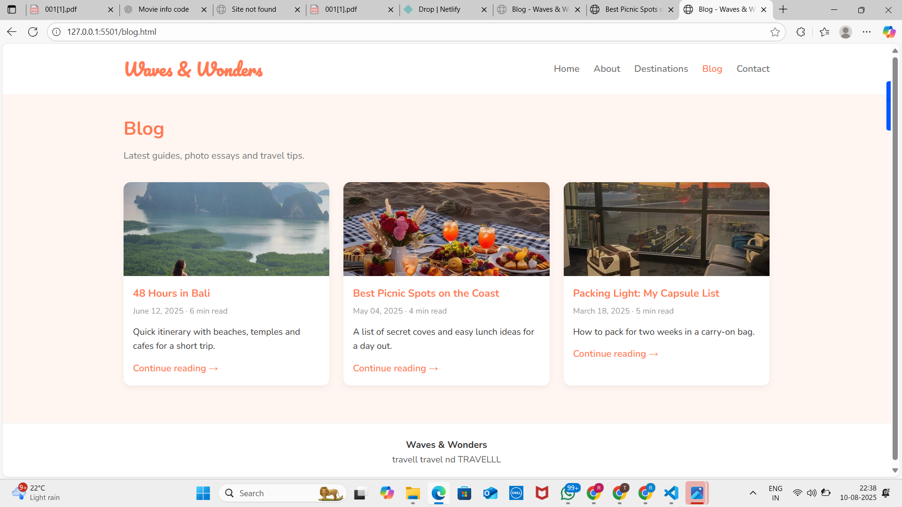

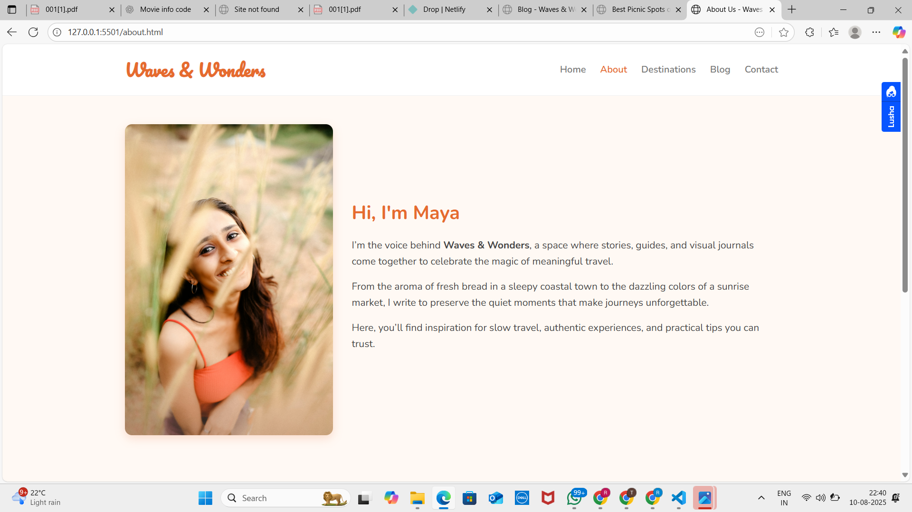

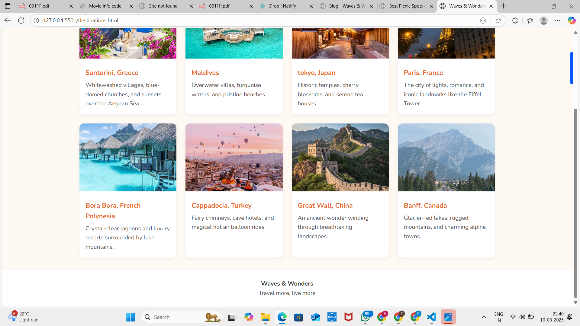

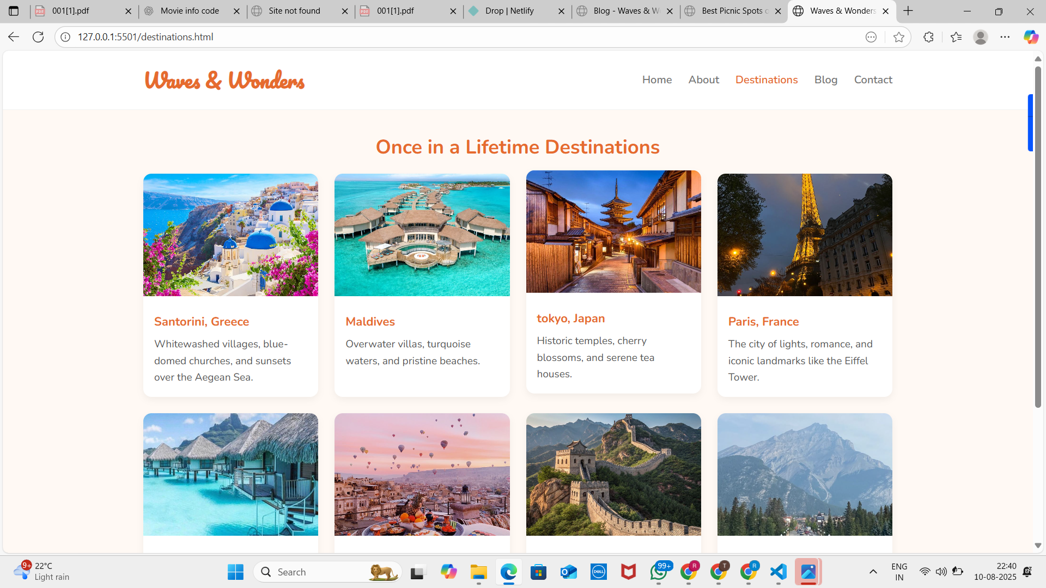

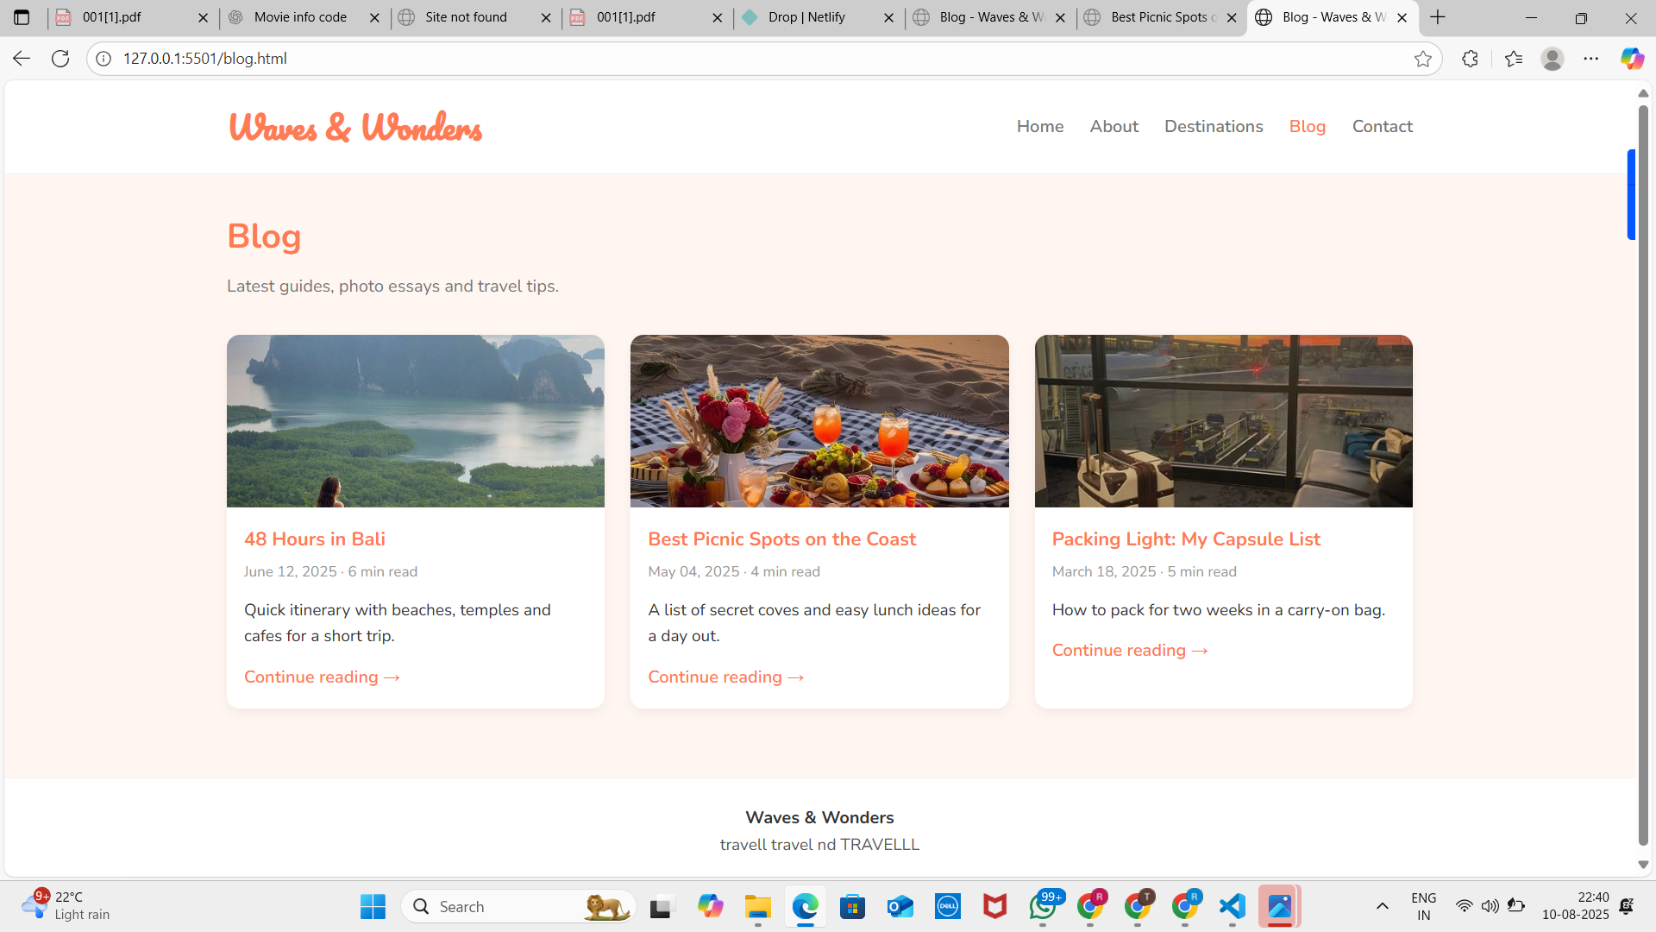

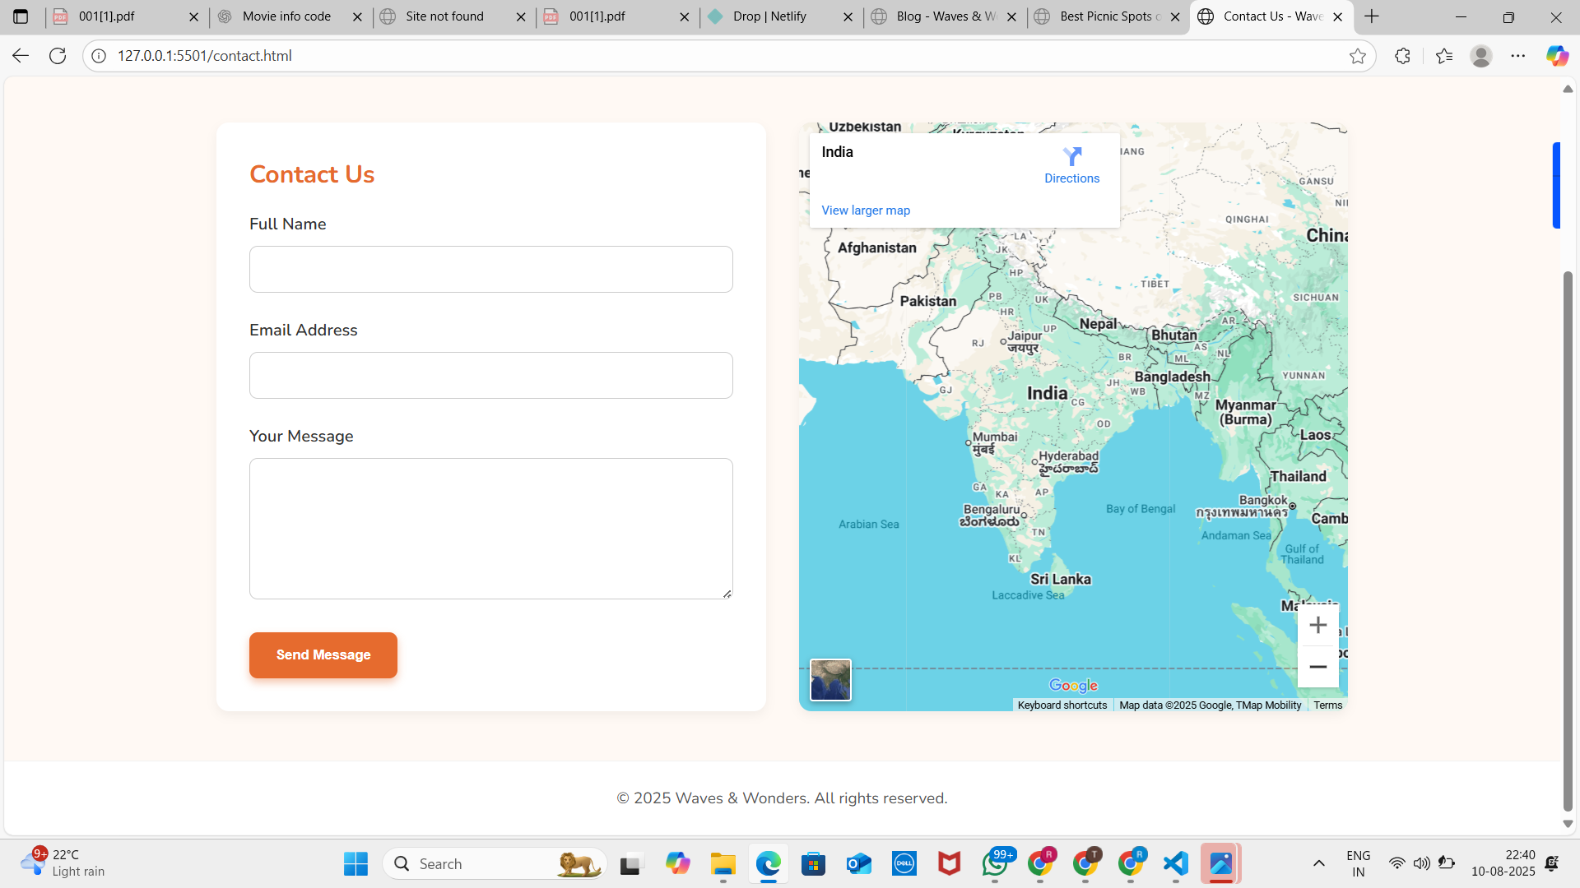

CONCLUSION

The **Waves & Wonders** blog successfully demonstrates the creation of a travel-themed website with **appealing visuals**, **smooth navigation**, and **responsive design**. The project provided valuable experience in **front-end web development**, combining design aesthetics with technical implementation.

REFERENCE

1. W3Schools – HTML and CSS Templates – https://www.w3schools.com/w3css/w3css_templates.asp

2. TemplateMo – Free HTML CSS Templates – https://templatemo.com

3. Nicepage – Travel Blog HTML Code – https://nicepage.com/hc/21070/travel-blog-html-code

4. Mobirise – Travel Blog HTML Templates – https://mobirise.com/html-templates/travel-blog/

5. CSS Zen Garden – The Beauty of CSS Design – http://www.csszengarden.com